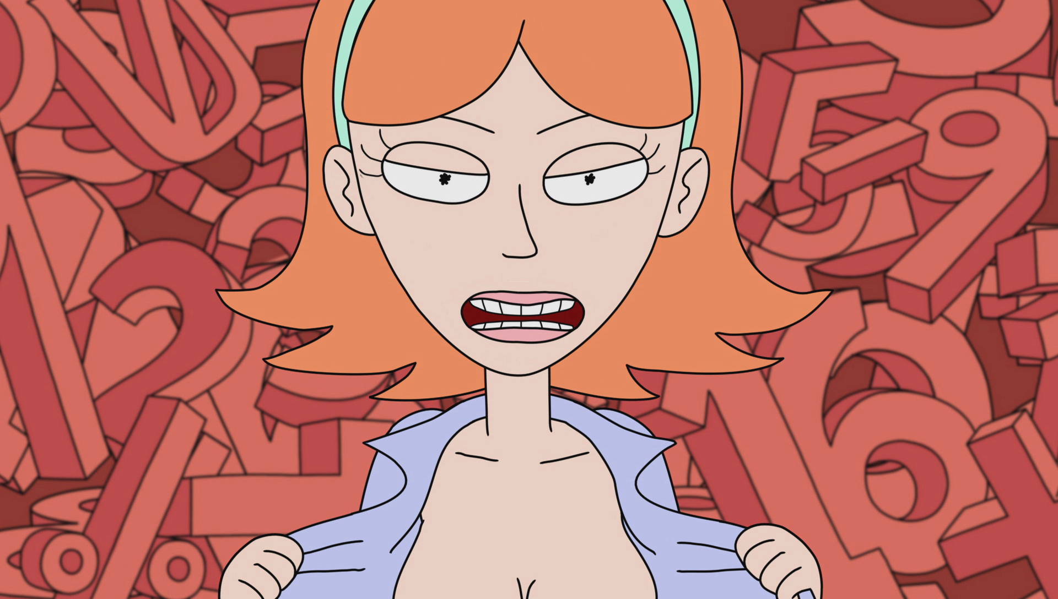

***NO! IT'S JUST A DREAM, MORTI! IT’S NOT TRUE!*** *There's no time to explain, you have to go deeper, to the next level ...*